Jonathan Lopez 11/14/2020
CS 2301 HW2
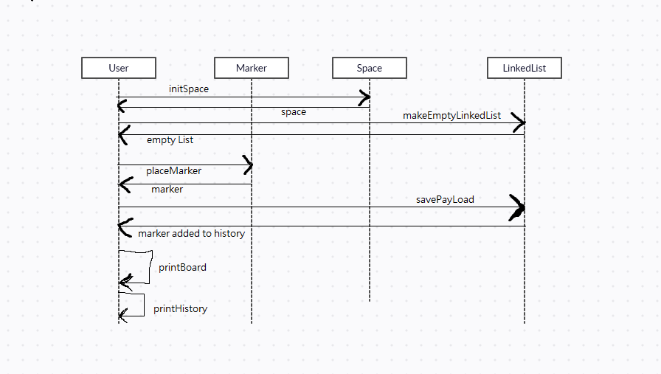
Sequence diagram

initSpace comes first to initialize the 20x20 array
it returns the space
makeEmptyLinkedList happens before any of the markers are placed
returns and empty list for now
placeMarker is called
returns a marker
which is then saved to the list with savePayload
that returns the list with the marker added
printBoard is called to print the new board with the markers
lastly printHistory is called to print the marker history

Test 1 figure 1

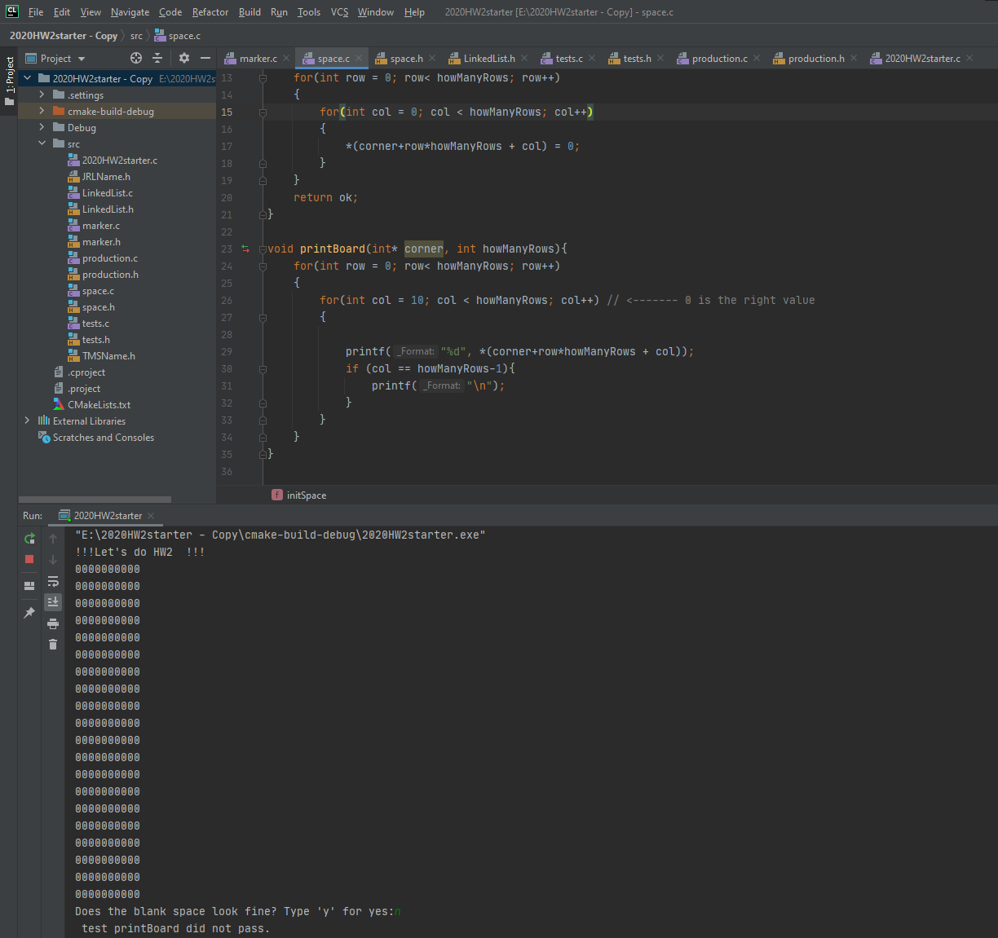

Test 1 figure 2
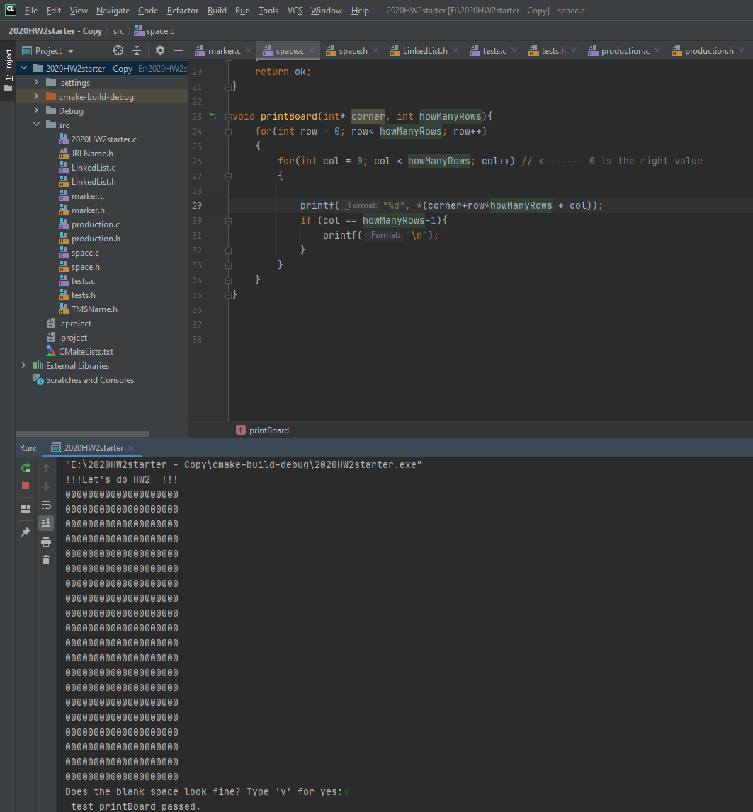

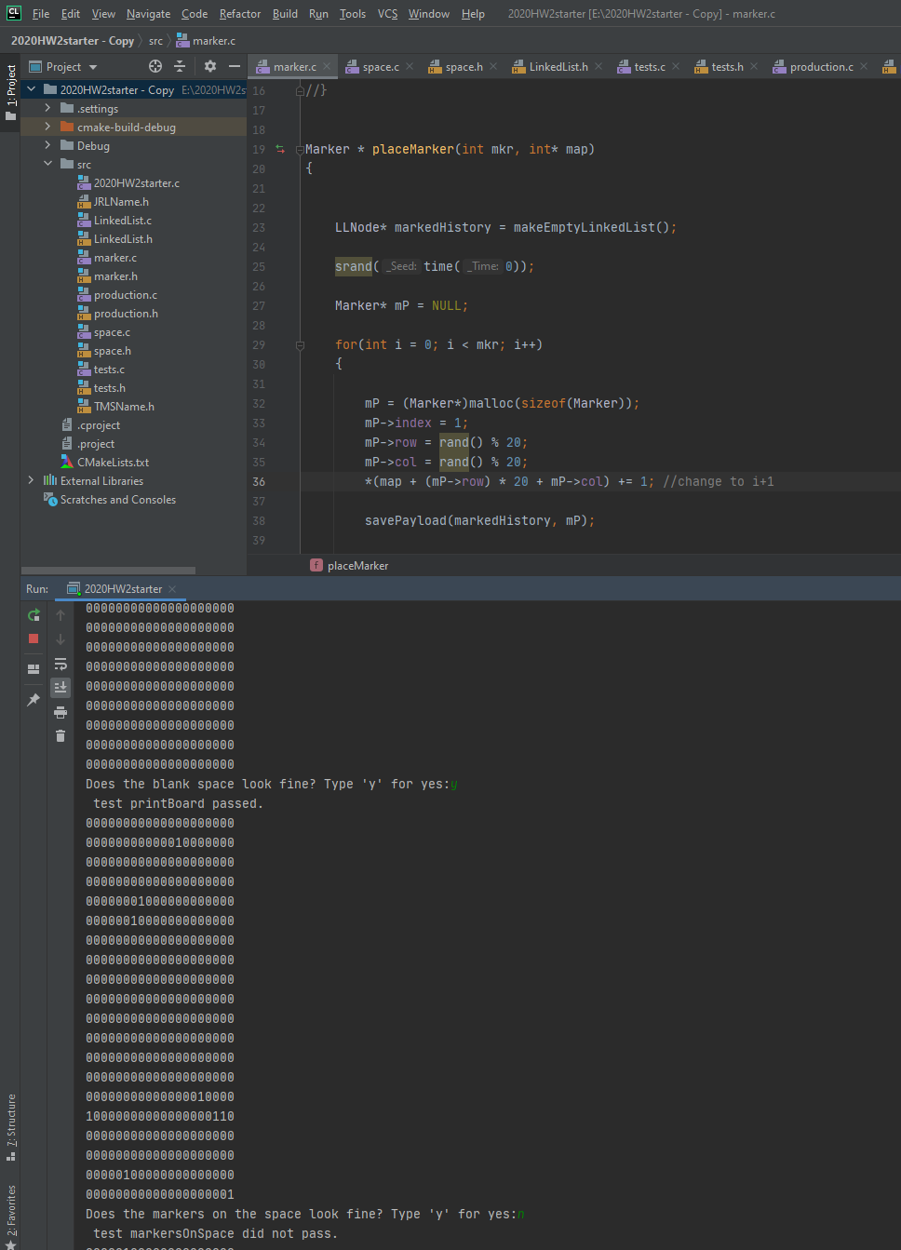
Test 2 Figure 1

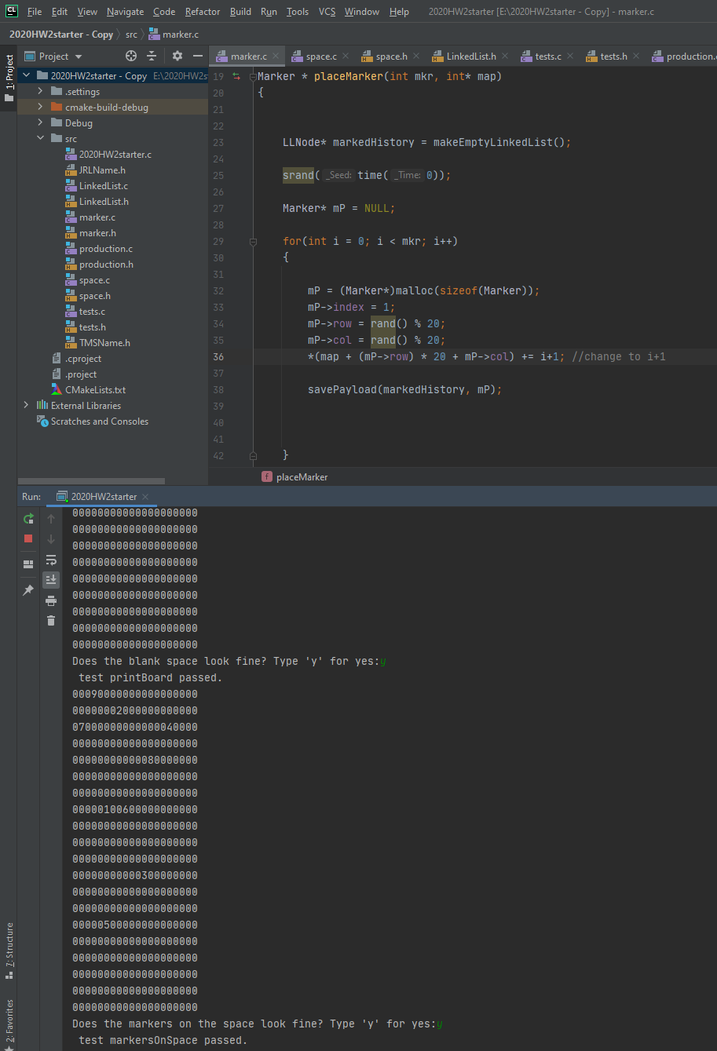
Test 2 Figure 2

Test 3 Figure 1
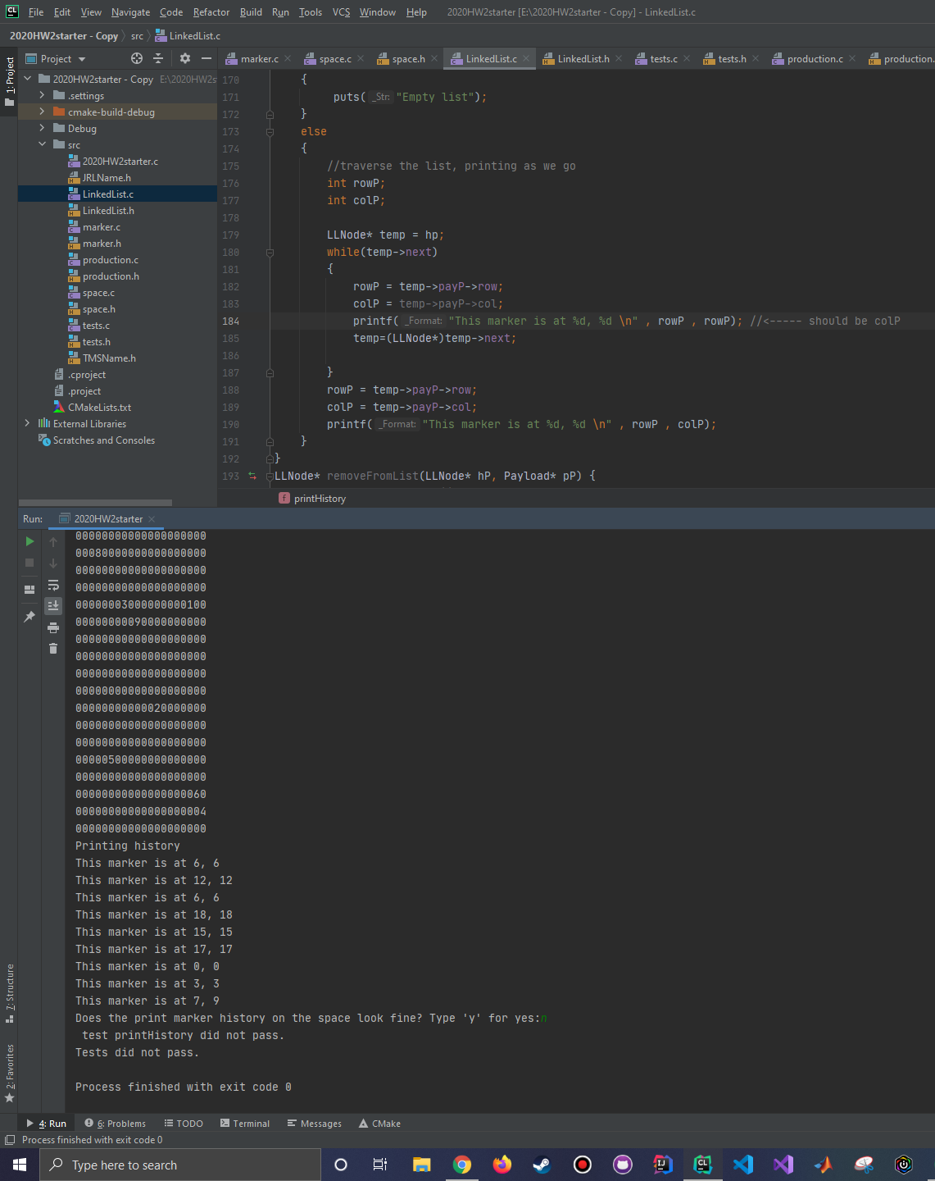

Test 3 Figure 2
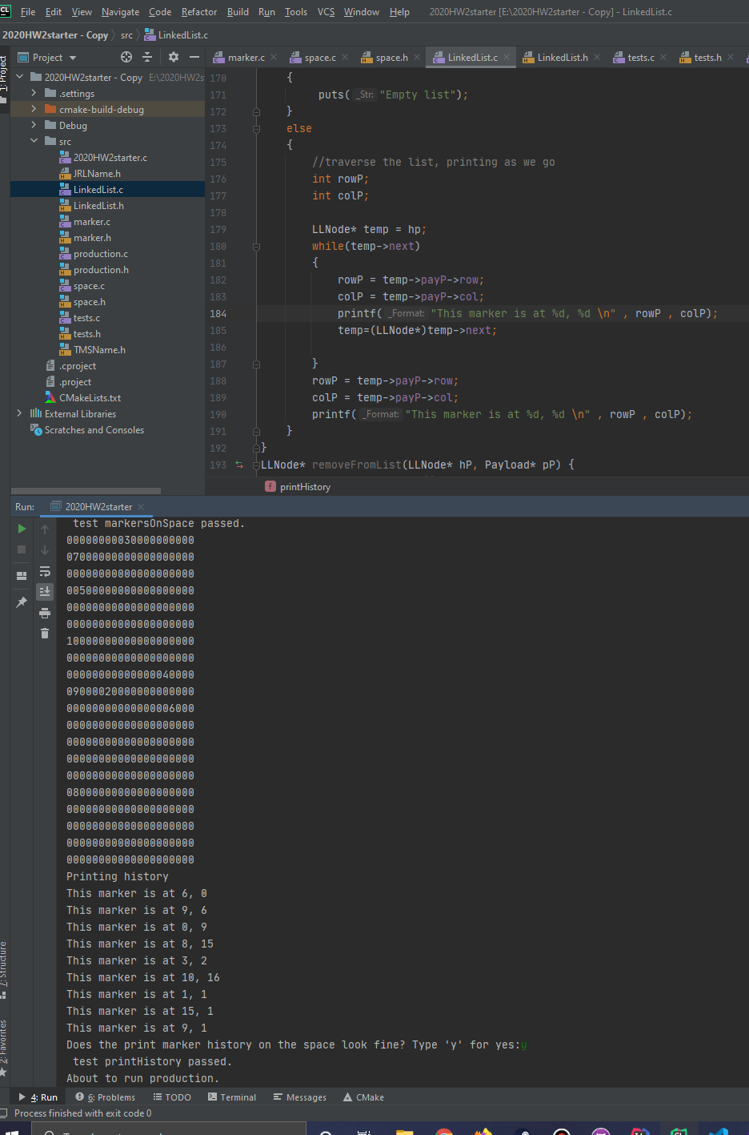

Comments:
Line1:
Made new tests and can be found in tests.c or on the previous page. They are stronger than last time
They do require typing ‘y’ to check to see if the function did what I Intend of it doing.

Line 2:
I put the empty LinkedList earlier in the code so it could keep calling it.
Also fixed it so printing the history at the end. (last line) of the sequence diagram

Line 3:
The screenshots should now look like figures 1 and 2 from the HW 2 PDF
Before: the stubs and failed tests
After: filled in stubs and passed tests
(Test Driven Development style)
Line 4:
set main back to the original starter code.

C-lion project zip is attached in canvas

Once they all pass it then runs production.
Production (after all tests pass)
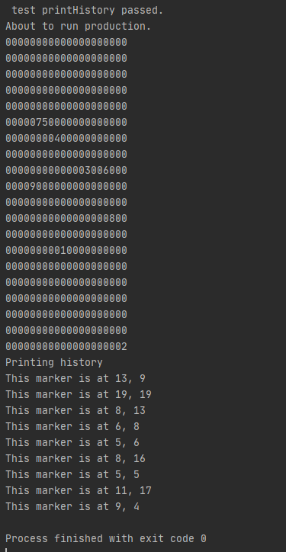

~Jonathan Lopez

